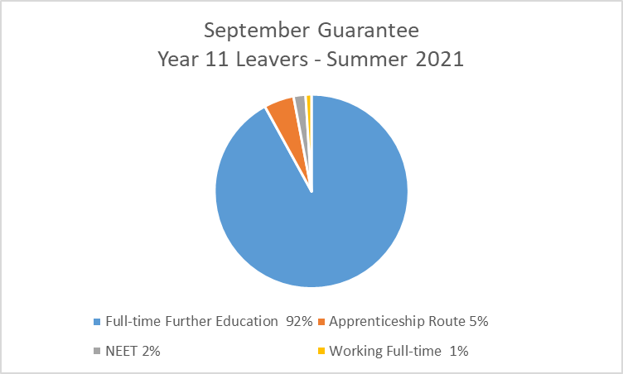

 | Full-time  Education | Apprenticeship  Route | Full-time  Employment | Armed Forces | Internship | NEET
2021 | 92% | 5% | 1% | 0% | 0% | 2%
2020 | 93.5% | 3% | 0.5% | 2% | 0% | 1%
2019 | 89% | 8% | 1% | 0% | 1% | 1%

